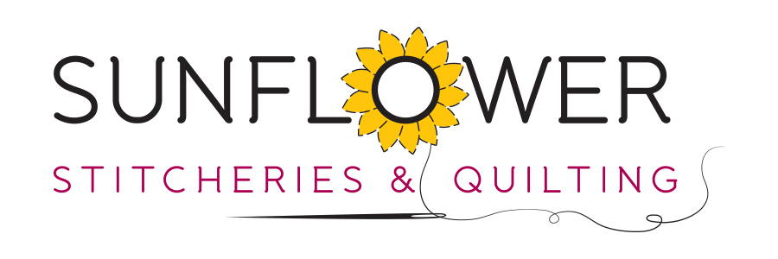
Be A Bee
You will need
- Fabric for embroidery – 14 x 14 inches. Depending on your intended use this will need to be adjusted. We intended to frame ours.
- Pen for tracing
- Iron-on Pellon or Parlan
- Embroidery Threads of your choice
To Make
- Trace the embroidery designs onto the fabric.
- Press your chosen stabilizer to the back of the fabric.
- Stitch the designs in your choice of threads.
The threads we used for this project are as follows
Magenta Bee – DMC Coloris #4504
Pink Bee – Cottage Garden Threads #610 Red Hot Poker
Stitches used are;
Stem Stitch, Back Stitch, French Knots

